Silver Jubilee Govt College (A), Kurnool
__________________________________________________________________
RESERVATION POLICY

Implementation of the Reservation policy of the State Govt. is the strategy adopted to improve access to students belonging to the categories of SC/ST, OBC, different categories of persons with disabilities, outstanding achievers in sports and extracurricular activities and Women. The percentage of reservation for the different categories is as follows.

SC | ST | OBC- 30% |  |  |  |  | PHC | Sports | Women
15% | 7% | BC-A | BC-B | BC-C | BC-D | BC-E | 2% | 3% | 33.3%
 |  | 7% | 10% | 1% | 7% | 5%

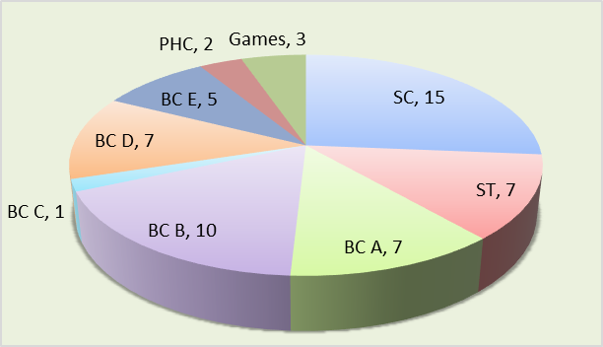

Rules of Reservation:
- Seats should be allotted based on the ranks within each category
- Preference should be given to those who have a higher percentage of deformity under physically challenged quota.
- For Sports quota, preference should be given to those participated in National/ State / Zonal /District level competitions respectively.
- There is no separate reservation for women like for disadvantaged communities and other special categories but the 33.3% of women reservation should be followed within each category including OC.
- Apart from the above categories, reservation is to be extended to NCC cadets and children of ex-service men.
- For consideration against NCC Quota, candidates should have Sr. Division B or A certificate. Preference is given to the children of ex-servicemen according to the parent's designation.

